11th January 2023

Dear BBKA member

I am writing to ask for your support for our SECOND honey petition which calls on the Government to change the Honey labelling rules so consumers can easily recognise all countries of origin of the honey contained in a jar sold here in the UK.  We urgently need as much support as possible to help us reach our goal of 100,000 signatures which means the Government must consider the issue for debate in Parliament.   The support of the general public and not just the beekeeping community is essential to achieve this result.

To find out more about the reasons we have raised this petition, please watch this short video: [https://youtu.be/szsyb1TDgzw](https://www.google.com/url?q=https://youtu.be/szsyb1TDgzw&source=gmail-imap&ust=1673456217000000&usg=AOvVaw0EVAfVnMNi5L8pFZJ94L8b)

To sign the petition – please click the following link:  [https://petition.parliament.uk/petitions/624402/](http://link.membershipservices.org.uk/ls/click?upn=qlsqTDJUhdcbONin573WnsaSYcBRGaV-2BUQ99b4Slr9Z-2BkvV9WqcgzYQwsKd7kiBlss-2B8C9Paekq6dnOtKLbZ8w-3D-3DmQZE_CGdrXD359dka6t58CL7pvhskCXR85HdCqbLwKQLNd2RzYf2LgU4pVmVD-2FPPoKfH7aYD6OCNffUFkEf6eKDiyorptpgY-2F-2FfiLNvIMm3kpuSjEdzQKx-2BADMeH97pbYf9kCYfuM5e-2FTp6uDutvmO3KMpElknUVoT4NsJBeARiOXgJ3lHSa2hnGJQ80AZ5ciIjQeUBC7b10VQ77IRuXJWTVFU9rwjxyrl6D-2FAlYcEKz3MNlBA8SXxyyxxRTI6qXZZ8yR60qsPNEDN87GdvGGYVjTJxBaKykW6Z9qSs2YcWBdHO7LWSxuL-2B5lFeFJEehXQW0IeTaL3w-2FmlELtovG7wpjh4Q-3D-3D)

***I think I’ve already signed the petition!***

Please note this is our 2nd honey petition so it is possible you are remembering signing the 1st petition.  To be sure, please click the link above – the system will tell you if you have already signed when you enter your email address.

***I’d like to advertise the petition when I sell my honey – can you provide any resources to help?***

There are a number of resources available on the BBKA website including QR codes with automatic links to the petition and some artwork:  <https://www.bbka.org.uk/downloadable-resources>

**How else can I help?**

If you are a user of social media, please share one of the BBKA social media posts:

<https://www.facebook.com/TheBritishBeekeepersAssociation/posts/pfbid02SxKiWnXHyTAQeGbqEfHBBjyi75RzXso6eBktnBoQr7xuqvWhTBVzp76Z4cVjBWiTl>

<https://twitter.com/britishbee/status/1610271112671203330?s=20&t=x2uqrp3MDeWhi3VEV69paA>  
<https://www.instagram.com/p/Cm9qctrphI0/>

You can also print off this QR code which can be scanned by your friends and family who have smartphones - they will be taken directly to the petition page:

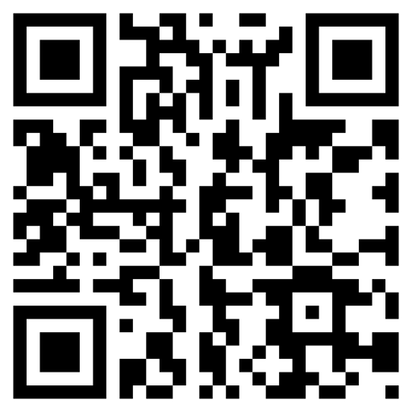

Finally, a big thank you to everyone who has already signed the petition – your support is greatly appreciated.

Kind regards

Stephen Barnes

BBKA Chair