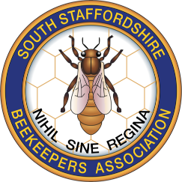

I would like to ask for your support with a campaign to raise awareness of the Asian Hornet.

The Asian hornet is a voracious non-native predator that unfortunately is trying to get a foothold in England.

Over 70 nests were located and destroyed in 2023, mainly in the south-east of England but also in Plymouth, Hull and Yarm in the North-East. It is almost inevitable that the Asian Hornet will appear in Staffordshire in 2024.

It is possible that queen hornets from these nests have overwintered and will emerge in spring to start new nests. This is when the help of the public is needed to report any sightings of these hornets, enabling nests to be found and destroyed.

The Asian Hornet poses a significant risk to members of the public and attrition of honeybees and other beneficial insects as well as consequences for agriculture, horticulture, and biodiversity.
One Asian Hornet nest can consume 12 kg of bees and other beneficial insects and pollinators in one year. This is the equivalent of 12 bags of sugar. Disturbing an Asian Hornet nest will lead to a vicious and persistent attack. Nests can be found high up in trees but also at ground level, e.g. brambles.
Controlling the spread needs help from the public to recognise it and then report it.
The easiest way to learn how to recognise and report the Asian hornet is by downloading
the “Asian Watch App” on your mobile phone. This can be done by scanning this QR code below.

More resources are available from the British Beekeepers Association:
https://www.bbka.org.uk/pages/category/asian-hornet-resource
And this is a useful video to be found on YouTube:
https://youtu.be/KVKbcZi5Zpc?si=3lxTyFXv8JXUBkwF

